Milestone #4 Project Evaluation

SENG310 Lab BO2 (Nirav?)  
  
Kyle Wilson – V00897204  
Kenil Shah – V00903842  
Jacob Thom – V00892893  
Kelly Hamilton – V00869519  
Spencer Hart – V00895336

**Heuristic Selection**

Our prototype relies heavily on

* **Recognition rather than recall**
  + Our prototype aims to reduce cognitive load on the users by having the actions available to them and simple to understand. This is achieved by having the steps in a process clearly stated in plain language. Additionally, buttons are mapped to images that an average user encounters in their daily lives.
* **Error prevention**
  + In its current state, our prototype consists of constraints to prevent errors in the form of alert boxes, which pop-up at the final stage of the task. These alert boxes clearly state, in plain language, what action is about to take place and has the option to cancel said action.
* **Consistency**
  + Our prototype relies heavily on consistency. It is important when a user is experiencing an application to not have to rely on memory to guide them. By using a consistent design, frequent visual landmarks will help users navigate.
* **Usability**
  + Usability helps users easily view and understand a given application. Our systems use visual clarity, and helpful design to make sure users can learn and understand the app without needing outside assistance.
* **Feedback**
  + Feedback lets users know that an action of theirs has had an effect on the app. This is especially important when dealing with company or personal documentation.
* **User Control**
  + User Control makes it so any task a user may need isn’t either locked behind redundant menus, or outright not available at all.
* **Accommodation**
  + Without accommodation, features that some users find necessary may not be present.
* **Technical Clarity**
  + By giving able users technical clarity, it helps them diagnose issues that may crop up during work. If a user runs out of available drive space, it is important that they are able to manage this without hassle. In a system that does not provide technical clarity, a drive cleaning utility may not be available to handle this.

**Cognitive Walkthrough Guide**

# **TASKS**

1. Goal: Rename multiple files  
   Brief: A user may want to do this when bulk uploading a series of images.  
   Steps:
   1. Long press on the images to highlight them
   2. Click the context menu icon on the top right of the phone
   3. Click “mass rename” in the menu that appears
   4. Press on the keyboard image
   5. Click “rename”
   6. Done!
2. Goal: Save all photos in a directory  
   Brief: A user may wish to save all the photos in a Google Drive folder to their local device.  
   Steps:
   1. Long press on images to highlight them
   2. Click the context menu icon on the top right of the phone
   3. Click “save to phone” in the menu that appears
   4. Done!
3. Goal: Sharing single file  
   Brief: A user may wish to share a single document to multiple people  
   Steps:
   1. Select the file by clicking on the ellipsis (context menu) below the file
   2. Click “share” in the menu that appears
   3. Click one of the following methods
      1. Choose a person to send it over text message
      2. Choose an app to send it via that app
      3. Choose “share with google” to share to another google account
      4. Choose “copy link” to copy a permanent direct link to the file that may be shared however the user decides.
   4. Done!
4. Goal: Moving a single file to a folder that is many directories away  
   Brief: A user may be reorganizing their drive and thus wish to recategorize an image  
   Steps:
   1. Select the file by clicking on the ellipsis (context menu) below the file
   2. Click “move” in the menu that appears
   3. Click the directory that either is to be the new location of the file *or* the directory that contains the subdirectory we to be the new location of the file
      1. Repeat as necessary
   4. Tap directory name again to move file
   5. Done!
5. Goal: Sorting files  
   Brief: A user may wish to look for a specific set of images based on shared characteristics that are sortable.  
   Steps:
   1. Select “sort-order-type”
   2. Choose by which method of sorting you would like
   3. Tap again to switch between most recent/least recent
   4. Done!
6. Goal: Cleaning drive folder  
   Brief: A user may wish to clean or declutter a folder of files that they no longer need. Caps on maximum allowed storage may influence this.  
   Steps:
   1. Press the newly created brush icon at the bottom
   2. A new menu opens that offers advanced file cleaning, and decluttering
   3. Choose appropriate method of cleaning files (Duplicate, Unused etc.)
      1. Custom select files or use the select all function
      2. Tap the delete/clean button at the bottom
   4. Choose a different method if necessary and repeat the above process
   5. Done!
7. Goal: To demonstrate sad paths for both “Mass Rename” and “Save to phone”  
   Brief: A user decides they want to save some files to their phone, but after starting the process decides against it.  
   Steps:
   1. Long press on the images to highlight them
   2. Click the context menu icon on the top right of the phone
   3. Press the darkened area of the screen to return without any action being taken
8. Goal: To demonstrate a sad path for cleaning drive folder  
   Brief: A user may wish to check the cleaning tool without cleaning their drive.  
   Steps:
   1. Press the newly created brush icon at the bottom
   2. A new menu opens that offers advanced file cleaning, and decluttering
   3. Press the file icon to return to the previous screen without any action being taken

Manifest

# Personas

John McMoney: 61 year old widowed man from the interior of British Columbia. He rarely uses his phone but is looking for an easy way to share documents with former colleagues and old friends. He has an iPhone since he was told they were the easiest to use, unfortunately he still struggles with it. His grandson downloaded the Google Drive app for him when he first got his phone, they thought it would be a good idea and would help him a lot. Since he is getting older, McMoney finds himself getting lonely without family and friends around. By complete chance most of his family moved away for work; unfortunately, this means that he doesn’t have a young person around to show him how to use it.

Timmy: 11 year old kid is an average middle schooler. He is only allowed to use smartphones under his parents’ supervision because his mother thinks they are a bad influence on him. Timmy wants to be an astronaut when he grows up. He is a brand new user when it comes to Google Drive, and struggles with the controls. Since he needs it for school, he doesn't like it very much. Since Timmy’s father already had the app installed on his phone, there was no need for him to know the process. He first heard of the Google Drive app when his teacher mentioned it as an upcoming test topic

Tommy: 35 year old male whose favourite colour is red. He aspires to become a professional chef after spending multiple years as a professional arm wrestler. Tommy likes the ability to create recipes and share pictures of his creations on the fly. He would really like to have the ability to download multiple images at once. Tommy is somewhat proficient at using his smartphone, he has been using it for several years and knows it well. He was recommended the Google Drive app after a friend of his started using it for work.

Jim McJoe: 38 year old data scientist that uses Google Docs to store company spreadsheets. Frequently makes changes to these and stores them in the cloud for company usage and review. He wishes there was better version control so that spreadsheets could be forked for multiple uses and scenarios as well as revision of past documents. He’s constantly on the go and tries to use the mobile application for its convenience and accessibility. As Jim is an experienced user, not only does he know how to use Google Drive like the back of his hand, he also understands it’s limitations. He heard of the app when it first came out through colleagues, and jumped on the opportunity to use it.

Photographer McShooty: uses Google Docs as a way of transferring photos between devices. When his photos are up in the cloud, he often shares sets of photos with clients. He is upset with the sharing interface often leading to making mistakes and sharing directories instead of subdirectories and that they gain editing privileges as default for the entire folder, allowing them to move around and alter/delete his work. He is further angered at the inability to download multiple photos at once to his cellular device.

# Scenarios

Scenario 1

John has just finished a new white oak coffee table and has taken some photos of his work. He wants to share them along with a write-up explaining the process he went through to get it to this point. He recalls the last time his grandson was over he downloaded Google Drive onto his phone for this type of situation. He opened his iPhone and clicked on the Drive app. He is greeted with a walkthrough of the application that he follows to make a new document for the newly made table. John added the photos along with his write up about how it was built. He sent it to a few former colleagues and friends and also made a special version that includes a thank you to his grandson for downloading the app on his phone the last time he came over.

## Scenario 2

Timmy, in his new year at middle school was forced by his parents to take a computer class. In the fifth week of this painfully boring class, his instructor — Mr. Scheit — is teaching the class how to use Google Drive and its companion apps (Google Docs, Slides, Sheets etc). He has decided that he is going to hold a practical test at the start of next week. Now, Timmy decides to join his family on a trip over the weekend. He promises his mother he will finish studying for the test during the night, on his father’s OnePlus 7T Pro. This proved very easy for Timmy, as the mobile app was very similar to the desktop. The app also had improved navigation, so it was easy for an average child like himself to not get disoriented.

## Scenario 3

Tommy has just completed the creation of his brand new lasagna recipe with his secret sauce. He opens the Google Drive application to download photographs of his creation from a shared folder for distribution to his phone for social media sharing. When Tommy navigates to the folder and selects the “download a file” option, the system gives him the option to download multiple images at once. Tommy is able to download all ten of his images from the folder at once.

## Scenario 4

Jim — by pure chance — has no time to use a computer when dealing with company data spreadsheets. He is constantly flying around the country from job site to job site, thus he needs to use the Google Drive app frequently. One day his boss wants him to download multiple spreadsheet files for review whilst on a business trip. Jim decided to download them all at once. He opened the Google Drive app on his phone and selected all of the files he needed. He clicked the download button and all of the files downloaded at once. Jim was happy with the ease of use and the process.

## Scenario 5

Mr. MsShooty is happily able to navigate the file structure without having to view the contents of folders he is not interested in. Once in his folder of choice, he is able to select all of the photos in no more than two taps. With all his photos to download selected, he is able to bring up a menu with a simple gesture and tap “save to photos”. His photos are now saved to his phone and he jumps for joy at how nice the Google Gods are to humanity.

# PROTOTYPES

**Sharing Tool**

|  |  |  |
| --- | --- | --- |
| Main page for a file folder | Menu if single object selected and ellipsis is clicked | Menu if multiple objects selected and ellipsis is clicked and ellipsis is clicked |
|  |  |  |
| If “move” is selected | If “share” is selected | If “open in…” is selected |

**A low-fidelity prototype of a mass renaming tool**

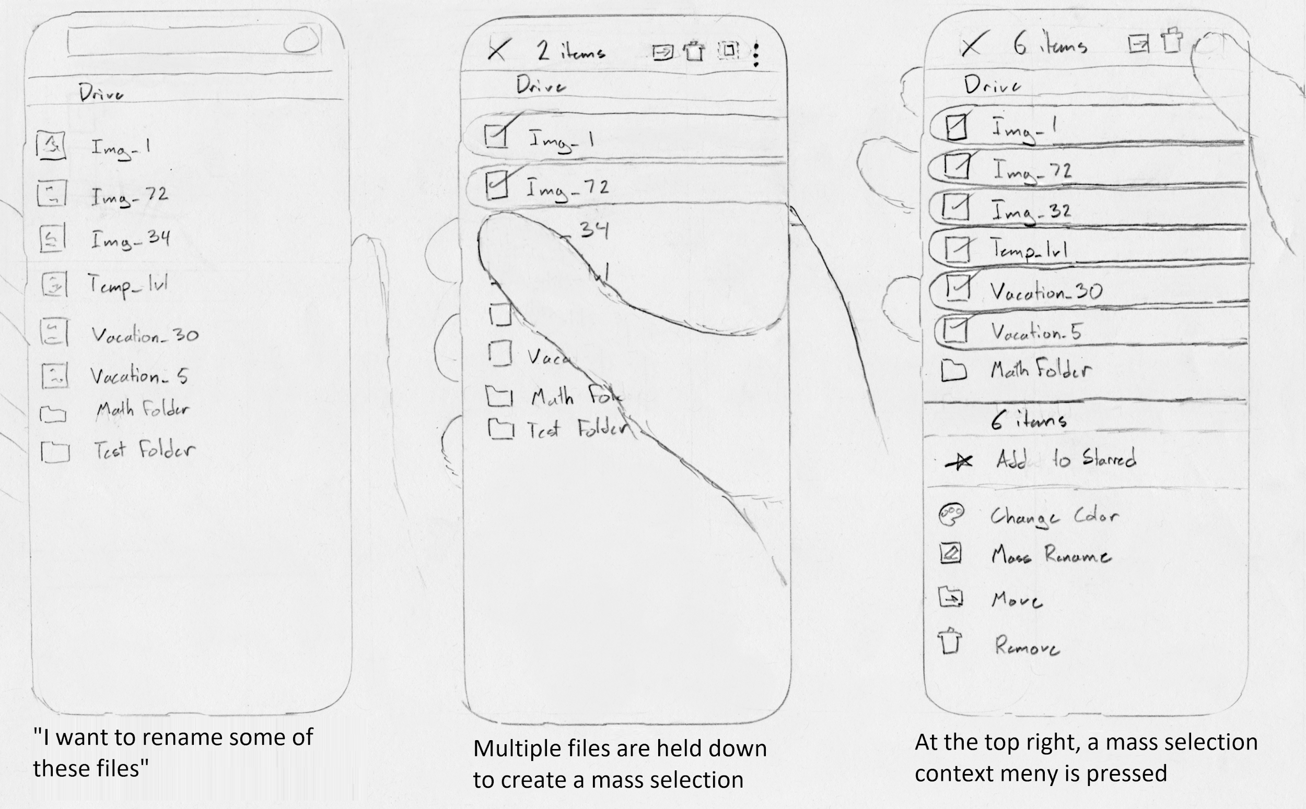

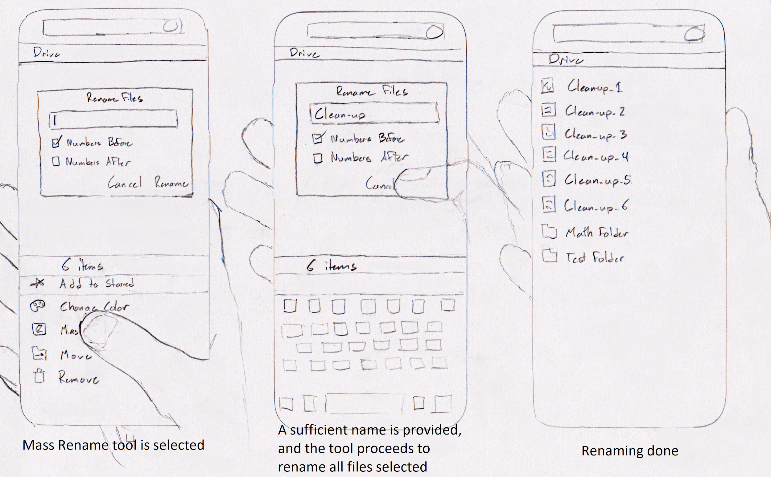

This prototype details an example mass rename tool. This feature is currently lacking within the current iteration of Google Drive. This tool may help with organization for those with countless files of a similar type, such as photographers and office workers. While this prototype is quite detailed in what it wishes to show, as it is a vertical prototype, it lacks a broader scope.

|  |  |  |
| --- | --- | --- |
| If the “create” function is used | If “sort” is selected | List of files |
|  |  |  |
| Multiple select options | Renaming files | Result of renaming |

Create is an example of the options presented to the user when they go to create a new object in their drive. They are presented with the usual options that you would expect, with additional options of Google partnered apps. Sorting is an important part of the app and it is giving you the arrows to sort by newest or oldest as well as all the sorting options you would want. Finally, a higher quality version of the mass rename tool that was talked about previously

**A low-fidelity prototype of sorting by date created**

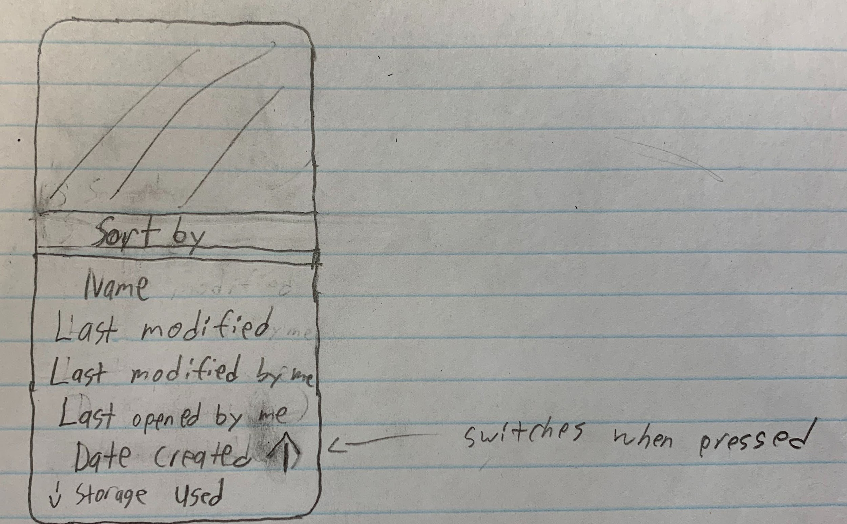

This prototype details an example of an additional sorting field for the Google Drive app. Currently, it lacks the ability to sort by the date that files were created. If already sorted by date created, re-selecting this option would invert the order between ascending and descending, as indicated by the arrow icon direction (up or down). A more polished version of this low-fidelity prototype will likely be included in future iterations of this project as it would be a useful feature that is currently lacking.

**A low-fidelity prototype of a clean tool**

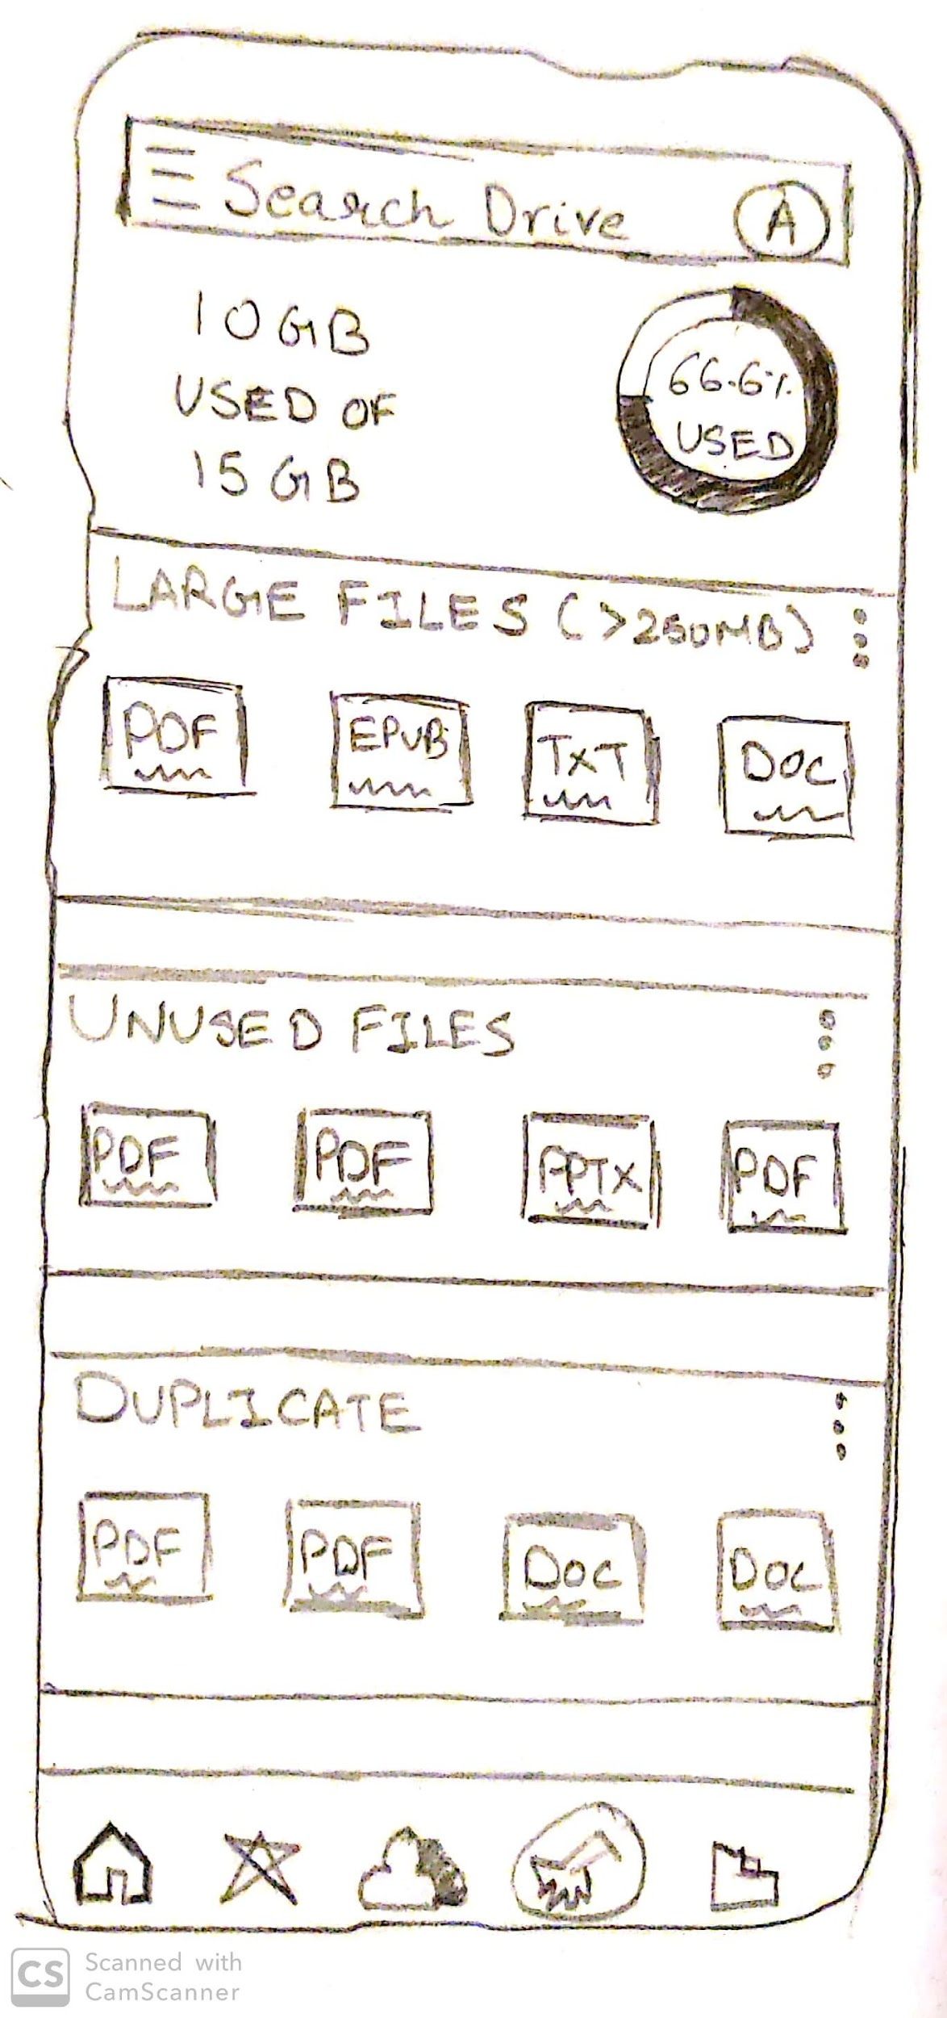

This is a prototype for incorporating a ‘clean’ function to the Google Drive app. Currently, users lack any tools to declutter or clean up their drive, making it a chore to efficiently delete unnecessary files. We would like to go into the functionality of such a tool in further iterations of the prototype.

# Medium Fidelity Prototype

**See “Medium Fidelity Prototype.pdf”, and use the clickable buttons to navigate**

Observations/Issues Recording System

For collecting and analyzing observations and issues, we will be relying on an observational spreadsheet. All incoming issues will be piped into the spreadsheet under different levels of urgency:

* **Critical**: Issues that stem from the core of the project. If left unchanged, may tarnish or break the core systems.
* **High**: Issues that should not be ignored, but may be okay to leave for a short period of time.
* **Medium**: Low risk issues. These may cause minor disturbances, but nothing permanent.
* **Cosmetic**: These more closely resemble observations than issues. Cosmetic issues are typically small and easy to fix, such as grammar or spelling mistakes.

The following is an example of findings from our lab

| Severity | Issue | Possible Fix | Status |
| --- | --- | --- | --- |
| High | Certain medium fidelity prototype links don’t work. When pressing the “Last modified” button on the home slide, nothing happens. Instead it should load the “Sort By 1” slide. | Open Balsamiq and link the two slides together. | Fixed |
| Cosmetic | On the Medium Fidelity Prototype, there are three linking arrows that all do the same thing on the “Home” Slide. These arrows are found on the “Temp_1shtyv3.jpg '' button. | Remove the clickable link status from two of the items | Ongoing |
| Cosmetic | On the Medium Fidelity Prototype, the “Vatacation.jpg” file on slide “Home”, “Mass_Selection 1”, “Mass_Selection 2”, etc should say “Vacation.jpg” | Change the name on all titles to Vacation.jpg | Ongoing |